附件3 英文论文排版格式

Temple for Preparation of Papers

First Author¹, Second Author^{1,2}, Third Author²
1. School of Traffic and Transportation Engineering, Changsha University of Science & Technology, 410004,Changsha, P.R.China
E-mail: aaa@csust.edu.cn
2. School of Civil Engineering and Architecture, Changsha University of Science & Technology, 410004,Changsha, P.R.China
E-mail: aaa@csust.edu.cn
Abstract: This is the paper style requirement. The writers of papers should and must provide normalized electronic documents in order for readers to search and read papers conveniently.
Key Words: Paper, Instruction, Graduate Innovation Forum of Hunan
长沙理工大学第十一届“研究生博力学术论坛”
征稿（论文）编写要求
第一作者¹，第二作者^{1,2}，第三作者²
1. 长沙理工大学 交通运输工程学院 长沙 410004
E-mail: aaa@csust.edu.cn
2. 长沙理工大学 土木与建筑学院 长沙 410004
E-mail: aaa@csust.edu.cn
摘 要：长沙理工大学第十一届“研究生博力学术论坛”为了提高论文集质量，我们为论文排版制定了统一规范。请按照此规范提供论文的最终版本。 注意：英文文章必须同时提供中文摘要和关键词。
关键词：论文，格式，电子文档

1 INTRODUCTION
These are instructions for authors typesetting . This document has been prepared using the required format. Please use this document as a “template” to prepare your manuscript. Do not delete the blank line immediately above the first section; it sets the footnote at the bottom of this column.

Instructions for Authors
According to the need of publishers editing ,each paper will be submitted DOC.
2 FORMATTING INSTRUCTIONS
MS Word Authors: please try to use the paragraph styles contained in this document.

Length
The maximum allowed number of pages is 6.

Page/Font Settings
It is strongly recommended that prospective authors download templates for use with MS Word.
Templates provided here have been created to ensure that margin requirement is adequately met. If, for some reason, you are not able to use provided templates, please observe the following margins and font settings strictly.
Table1. Page Margins
Paper Size | 21×29.7cm
Top Margin (1st page) | 2.54cm
Top Margin (rest) | 2.54cm
Left Margin | 2.54cm
Right Margin | 2.54cm

Table2. Font Settings
Title | Times New Roman, 16pt,bold
Author List | Times New Roman, 10.5pt
Authors’ Address | 10.5pt
Abstract, Key Words | 10.5pt
Section Titles | 14pt,bold
Subsection Titles | 10.5pt,bold
Normal Text | 10.5pt
Table/Figure Captions | 9pt
Footnotes | 8pt
References | 10.5pt

  - Section and Subsection Headings
Number section and subsection headings consecutively in Arabic numbers and type them in bold. Avoid using too many capital letters. If any further subdivision of a subsection is needed the titles should be 10.5 point and flushed left.
  - Main Text
Use Times New Roman with font size 10.5 point for text (character size). Paragraphs are separated by 6 point and with no indentation. You may type on plain white A4 paper.
  - Tables
All tables must be centered in the column and numbered consecutively (in Arabic numbers). Table headings should be placed above the table. Place tables as close as possible to where they are mentioned in the main text (see Table1 and Table2).
  - Figures
All illustrations should be original drawings or photographic prints of originals. Photographs should be glossy prints. Photocopies are often not good enough and should be avoided. All illustrations must be numbered consecutively, using Arabic numbers. Center figure captions beneath the figure (see Figure 1). If possible, do not assemble figures at the back of your article, but place them as close as possible to where they are mentioned in the main text. No part of a figure should go beyond the typing area. Captions should appear below graphical objects, as in Figure 1.
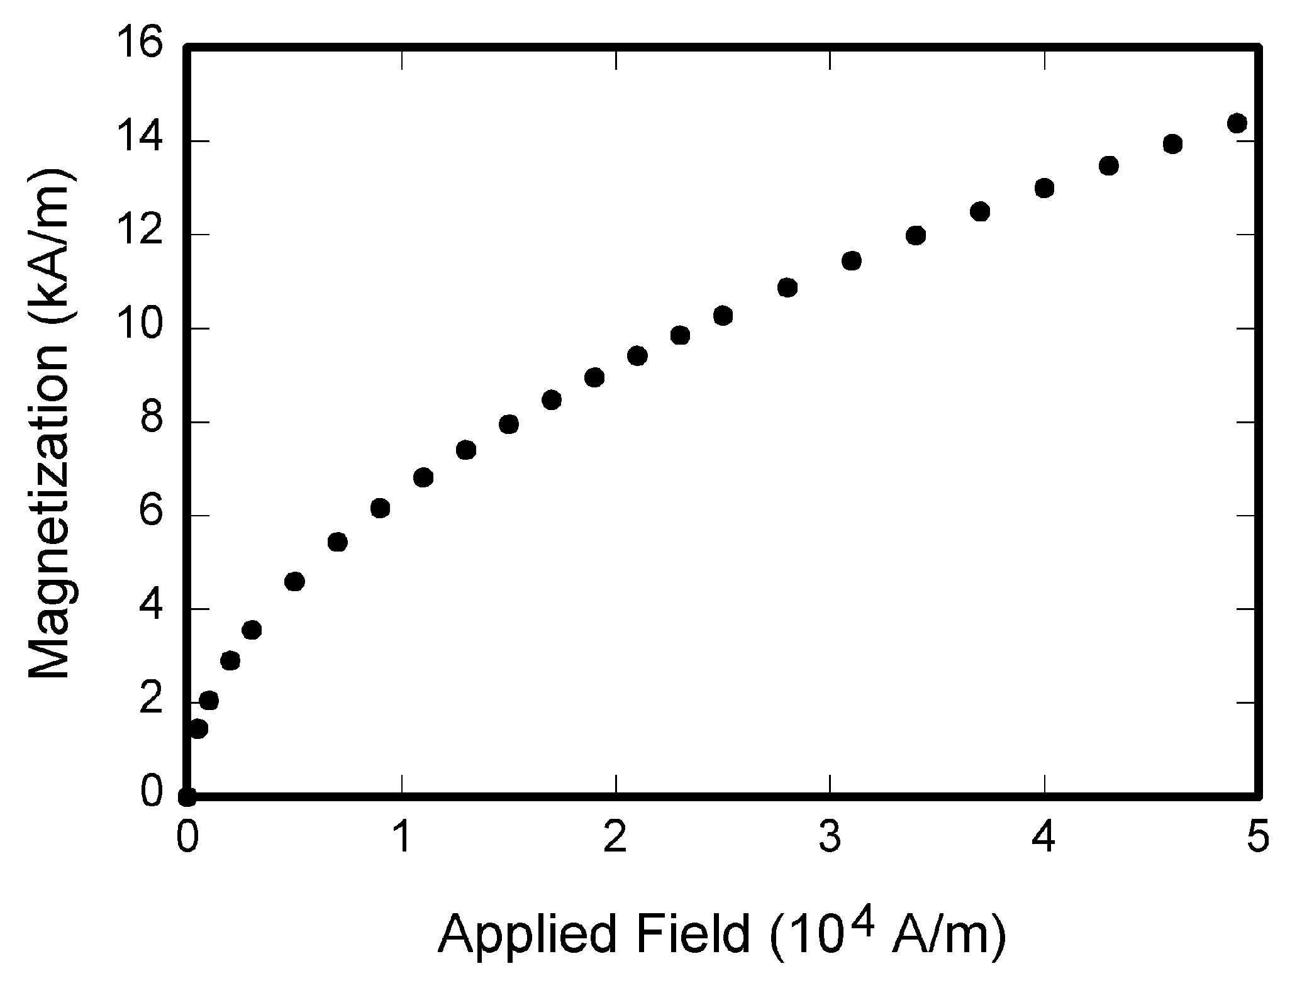
Fig 1. Magnetization as a function of applied field. It is good practice to explain the significance of the figure in the caption.

Color and grayscale figures should be prepared with 400 dpi resolution and saved with no compression, monochrome figure should be prepared with 600 dpi resolution and saved with no compression.
  - Mathematical Formulas
Mathematical formulas should be roughly centered and have to be numbered as formula (1).
(1)
  - References
Number citations consecutively in square brackets [1]. The sentence punctuation follows the brackets [2].
Please note that the references at the end of this document are in the preferred referencing style. Give all authors’ names; do not use “et al.” unless there are six authors or more. Use a space after authors' initials.
3 FINE TUNING
- Do not end a page with a section or subsection heading.
- Do not include page numbers in the text
4 PAPER SUBMISSION
After proofreading your paper, it must be sent to the relevant E-mail electronically including both MS Word and PDF formats.
References
- D. Z. Cheng, Controllability of switched bilinear systems, IEEE Trans. on Automatic Control, Vol.50, No.4, 511-515, 2005.
- D. Z. Cheng, Matrix and Polynomial Approach to Dynamic Control Systems, Science Press, Beijing, China, 2002.
- D. Z. Cheng, On logic-based intelligent systems, Proceedings of 5th International Conference on Control and Automation, 71-76, 2005.

